Urinary Retention

The sun rises over the San Joaquin Valley, California, today is April 29, 2020. Clinica Sierra Vista’s CEO, Brian Harris, resigned from his position on April 24. We appreciate Brian’s leadership and enthusiasm. He brought positive changes to this institution, and we wish him a successful future.
How many times have you checked UpToDate today? UpToDate is probably one of the most used point-of-care reference tools in the world. We’d like to recognize the work of Dr. Burton (Bud) Rose, the founder of UpToDate, who passed away on April 24. Thanks, Bud, for your contributions to the spreading of evidence-based medical knowledge.
This week the media have been flooded by comments about “disinfectants”. A disinfectant is a chemical that destroys vegetative forms of harmful microorganisms (such as bacteria and fungi) especially on inanimate objects. President Trump discussed with experts the possibility of developing a “disinfectant” that can be injected to kill SARS-CoV2 inside the body. An official recommendation to “inject disinfectants” was not issued, but misinterpretations and countless remarks, comments, and jokes were made. Please make sure to tell your patients that common household disinfectants are for external use only.
Quote: “Everybody is a genius. But if you judge a fish by its ability to climb a tree, it will live its whole life believing that it is stupid.” Albert Einstein.
Dear Residents, what are you good at? What are your talents? I invite you to explore those things you know how to do, and continue to perfect them, we are all geniuses. Today our guest is Dr. John Ihejirika. John is one of our second-year residents in the program. We ask 5 questions in this podcast. We’ll start with the first question.
- Question number 1: Who are you?
My name is Dr. John Ihejirika. I am one of the second-year residents at the Rio Bravo Family Medicine Residency Program, here in Bakersfield California.
I am originally from Nigeria. My last name was quite a battle for most of my colleagues/coworkers to pronounce at the beginning, but most have now figured out the almost perfect pronunciation, but some still call me Dr. “Ihe” or Dr. “I”, which is still ok, ha-ha. It is pronounced “E – hay- gi- ri- car” which in my local language literally means “What I have that makes me greater than you”. I grew up in a very humble family and attended and graduated from the College of Medicine University of Nigeria after which I practiced for a few years in General practice especially in very low resource limited communities before immigrating to the United States.
It was always my dream to further my Medical career in the US, so with lots of studying, effort, persistence, hopes and prayers I find myself here today in the mist of such a wonderful group of Residents and Faculty, and lucky to be in one of the best Family Medicine Residency Programs in the country. Some of my hobbies are cooking especially Nigerian dishes, playing soccer, traveling, meeting people of different cultures, and watching movies. I am very pleased to be here today and thank you for having me.
- Question number 2: What did you learn this week?
What I learned this week was about the management of acute urinary retention (AUR).
Acute urinary retention is defined as the inability to voluntary pass urine.
I had a 68 y/o male patient that came to the clinic as a walk-in for complaints of lower abdominal pain and constipation since the previous night. Upon further questioning, I realized that he had not urinated in over 12 hours, and physical examination revealed lower abdomen/suprapubic tenderness and distention. We were able to get about 1L of urine after straight catheterization in clinic with complete resolution of his symptoms.
AUR is usually common in older men and etiologies may include (1) Outflow obstruction (most common) e.g. Benign prostatic hyperplasia BPH, (2) Neurologic impairment, e.g. damage of sensory or motor nerve supply to the detrusor muscle like in spinal cord injuries, demyelination syndromes or neuropathy, (3) Inefficient detrusor muscle, (4) Medications, e.g. anticholinergics, sympathomimetic and some muscle relaxants, (5) Infections, e.g. acute prostatitis, and 6. Trauma.
Evaluation of patients with AUR
Initial evaluation involves getting a thorough history and Physical examination which usually reveals a patient in discomfort with suprapubic tenderness and distention. We usually pass a 14-18 Fr urethral catheter (depending on degree of resistance) to decompress the bladder and note the amount and color of urine collected. If urinary output is less than 150ml, AUR is less likely.
Urine samples should be sent for urinalysis and culture. Other labs like a Basal metabolic panel (BMP) to assess any possible damage to kidney from chronic retention. PSA is usually not ordered because it can be elevated in acute episodes of urinary retention. If the urinary output exceeds 400 mL, the catheter is usually left in place for about 3-5 days after which a voiding trial is done.
If postvoid residual urine volume is >300ml or patient still has lower urinary tract symptoms after the voiding trial, the catheter is usually kept in place until evaluation by Urology.
Medications
An alpha-1-adrenergic blocker (tamsulosin) and 5-alpha reductase inhibitor (finasteride) medications are usually prescribed, and a referral to Urology is placed at the time of initial catheterization.

Contraindications of catheterization
Urethral catheterization may be contraindicated in patients who have had recent urologic surgery, trauma to or structurally abnormal urethral opening (meatus), or failed urethral catheterization even with the smallest 10 or 12 Fr catheters. These patients should be referred urgently to Urology for possible suprapubic catheterization.
Complications after drainage of urine with a catheter.
Some complication can occur during bladder decompression, which may include; Hematuria (usually resolved spontaneously or with irrigation), transient hypotension and Post obstructive diuresis (which is usually seen in chronic urinary retention).
Post obstructive diuresis.
Postobstructive diuresis is defined as as urine output of 200 mL/hr for two consecutive hours or >3L/24hours. It is a polyuric response initiated by the kidneys after the relief of a ureteral obstruction to eliminate accumulated solute and volume(2). This can be managed by increasing fluid intake in patients who are unable to do so or have severe post-obstructive diuresis, we measure the urine output and replace one half the urine volume with half normal saline. For example, 1 litter of urine should be replaced with 500 mL of normal saline.

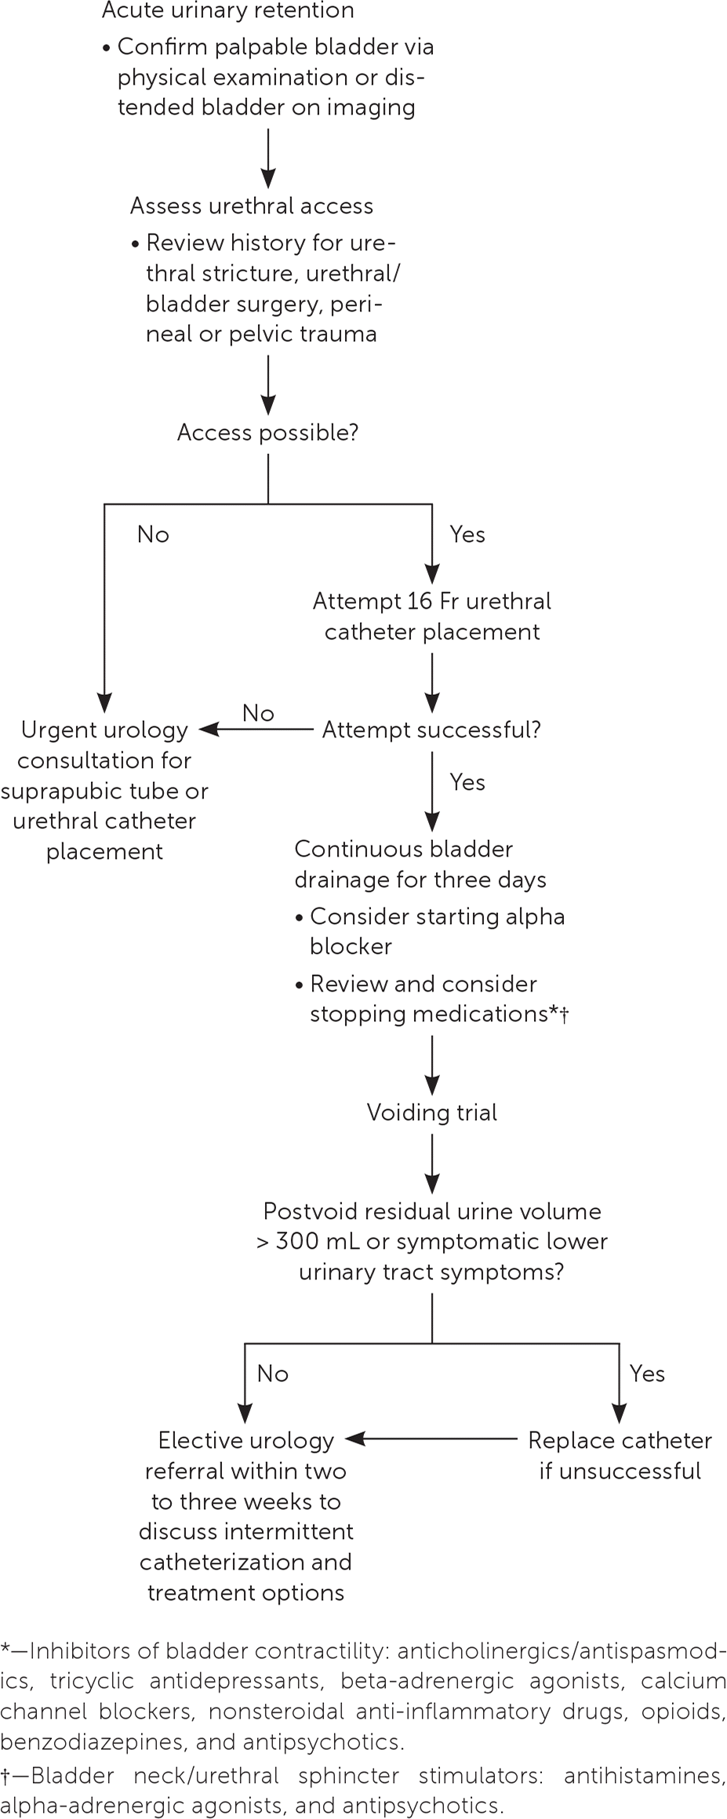
Summary of Management of AUR⁽⁴⁾.

- Question number 3: Why is that knowledge important for you and your patients?
Acute urinary retention is a very painful and uncomfortable situation for the patient, and It is the most common urologic emergency in men. It is also important for patients as it may be the first sign of a prostate abnormality/enlargement like BPH, as some men may not have the classic signs and symptoms of lower urinary tract obstruction previously. It is important for you as the provider because you should be able to look out for the signs in the history e.g. constipation, inability to voluntary urinate etc. and on physical examination for patients that may be presenting with AUR especially when working in an Urgent care or Emergency room. It also provides a mutual sense of satisfaction to both patient and provider especially when a prompt diagnosis is made and with immediate relief of symptoms after bladder decompression.
- Question number 4: How did you get that knowledge?
I got this knowledge from my faculty, Up to Date, Review/Journal articles and from some of my personal experience.
- Question number 5: Where did that knowledge come from?
This knowledge came from one of our very knowledgeable faculty here Dr. Parker, An article titled “Urinary Retention in Adults: Evaluation and initial management” from the AAFP website; “The Management of acute urinary retention” from the American Journal of Medicine; and “Acute urinary retention” review topic on Up-to-Date. You can see our website for further details on theses references.
Comment: Insertion of a urinary catheter needs to be learned. I recommend you guys review the technique and practice with your nurses how to place a Foley. Maybe we can have a workshop about catheter placement. It’s important to remember the size 14-18 Fr, you can use a larger one in case of BPH.
____________________________________
Speaking Medical: Tumescence
by Steven Saito
During our daily COVID updates we are given ways to relieve stress for our medical workers. Today we were told that self-massage was a useful form of stress relief. Back in the military, when they told me I could massage myself, they did not use as polite a phrasing.
In keeping with the theme, the word of the day is tumescence. Tumescence is the quality or state of being tumescent or swollen. Tumescence usually refers to the normal engorgement with blood of the erectile tissues. Nocturnal penile tumescence is a spontaneous erection of the penis during sleep or when waking up. Along with nocturnal clitoral tumescence, it is also known as sleep-related erection. All men without physiological erectile dysfunction experience nocturnal penile tumescence, usually 3-5 times during a period of sleep, typically during rapid eye movement (REM) sleep.
Nocturnal penile tumescence (NPT) testing can be used in diagnostic work up for erectile dysfunction. Monitoring devices are now available that provide accurate, reproducible information quantifying the number, tumescence, and rigidity of erectile episodes a man experiences as he sleeps. Nocturnal penile tumescence testing is generally performed when the clinician is trying to assess between psychogenic and organic erectile dysfunctions (ED). Typically, men with psychogenic ED will have normal NPT results. Physiologic ED will have impaired NPT results.
Espanish Por Favor: Mal de Orín
by Roberto Velazquez
The Spanish word for the week is “Mal de orín”, which is actually three words: Mal – de – orín, meaning: the disease of the urine, and obviously, people use this phrase when they have any urinary symptoms, most commonly: dysuria, urinary frequency, and/or foul-smelling urine.
The scenario when your patient complains of “mal de orín” may sound: “Doctor, tengo mal de orín, y no dejo de ir al baño”, what they are trying to tell you is “Doctor, I have dysuria and I may have a UTI”. As temperatures continue to raise this summer, I recommend you assess your patient’s hydration status too. Highly concentrated urine may have a stronger smell and may be confused with “mal de orín”. Now you know the Spanish word of the week, “Mal de orín”, all you need to do is to assess your patient’s “mal de orín”.
For your Sanity
By Alejandra Felix (MA) and Monica Kumar (MD)
Ale: My doctor told me to start killing people, well, not in those exact words, he told me to reduce stress in my life. Same thing.
Ale: Doctor, I have a cucumber up my nose, a carrot in my left ear and a banana in my right ear, what’s the matter with me?
Dr Kumar: Oh my, you are not eating properly!
________________________
Conclusion: Did you know that our In-Training Exam scores in 2019 were low in male reproductive medicine? That’s why our episode number 10 was filled with “manly” topics. Dr Ihejirika talked about Acute Urinary Retention, a condition that can be effectively diagnosed and treated, resulting in a relieved patient, a satisfied resident, and a proud attending. We stayed in the same anatomical area and remembered the word tumescence, and learned the Spanish phrase “Mal de orín” as a sign of possible UTI. At the end of the episode, our MA Alejandra was a little stressed. Don’t blame her, we had a long day in clinic.
This is the end of Rio Bravo qWeek. We say good bye from Bakersfield, a special place in the beautiful Central Valley of California, United States, a land where growing is happening everywhere.
If you have any feedback about this podcast, contact us by email RBresidency@clinicasierravista.org, or visit our website riobravofmrp.org/qweek. This podcast was created with educational purposes only. Visit your primary care physician for additional medical advice.
Our podcast team is Hector Arreaza, John Ihejirika, Golriz Asefi, Steven Saito, Roberto Velazquez, Monica Kumar, and Alejandra Felix. Audio edition: Suraj Amrutia. See you soon!
________________________
References:
- Merriam-Webster Dictionary, https://www.merriam-webster.com/dictionary/disinfectant
- Singh, Amardeep and Bhagwan Dass, Cureus Journal of Medical Science, “Post-obstructive Diuresis: A Cautionary Tale”, December 8, 2019, https://www.cureus.com/articles/25149-post-obstructive-diuresis-a-cautionary-tale
- Fitzpatrick JM, Kirby RS., Management of acute urinary retention. BJU Int. 2006;97 (suppl 2):16–20, discussion 21–22. https://www.amjmed.com/article/S0002-9343(09)00496-3/fulltext
- “Urinary Retention in Adults: Evaluation and initial management” by DAVID C. SERLIN, MD; JOEL J. HEIDELBAUGH, MD; and JOHN T. STOFFEL, MD, University of Michigan Medical School, Ann Arbor, Michigan, AAFP. 2018 Oct 15;98(8):496-503.
https://www.aafp.org/afp/2018/1015/p496.html
- Glen W Barrisford MD, Graeme S Steele MD, “Acute urinary retention”, Up to Date.
https://www.uptodate.com/contents/acute-urinary-retention?search=acute%20urinary%20retention&source=search_result&selectedTitle=1~88&usage_type=default&display_rank=1

